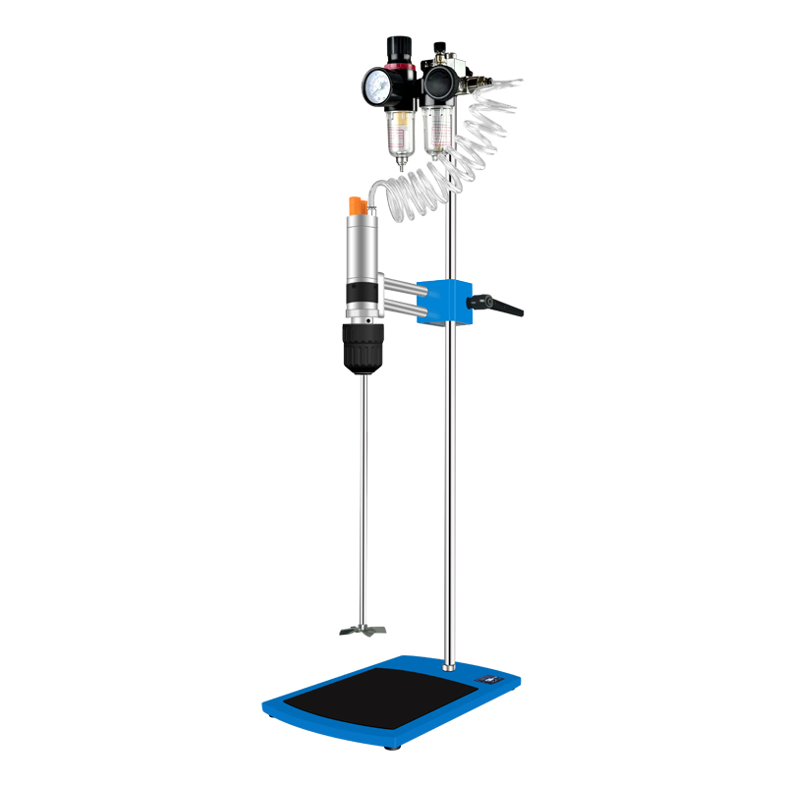

# **HJQ-2 Pneumatic Mixer**

# **HJQ-2 Pneumatic Agitator**

# **Shaker**

# HT-S330 **Rotary Shaker**

**Application：**

HJQ-2 pneumatic mixer using high-quality pneumatic motor to compressed air as the working medium of the prime mover, using the expansion of compressed gas, the pressure energy into mechanical energy power device, so as to achieve the experimental environment of the sample stirring and mixing, etc., especially suitable for with flammable and explosive substances or high-temperature environment on the paint, chemicals, solvents, such as the mixing.

**Main Features：**

* Small size, high power, safe and light operation;
* With high rotational torque, it can start with load;
* Standard pressure gauge, you can check the pressure value at any time;
* Imported self-locking chuck with self-locking function, high concentricity and long service life;
* The square lifting clamp use double hole mode, the height can be adjusted arbitrarily, the clamping is stable, and the operation is more stable;
* The whole machine adopts high-quality air motor with explosion-proof, no spark and no static electricity, which is safe to operate and not easily affected by external environmental factors;
* Various specifications of stirring paddles are available.

**Technical Parameters：**

|  |  |
| --- | --- |
| Model | HJQ-2 |
| Torque(N.cm) | ≤80 |
| Motor power（W） | 150 |
| |  | | --- | | Ventilation pressure(bar) | | 0~6 |
| Viscosity(cp) | ≤5000 |
| Speed(rpm) | 3000 |
| Rotational torque(N.cm) | ≤80 |
| Standard propeller | Four Blade Stirring Paddle |
| Fix mode | Self locking clamp |
| Mixing capacity(ml) | 50-30000 |
| Handle Method | Batch processing |
| Allowable ambient temperature(℃) | 5~40 |
| Allowable ambient humidity(%) | 80 |
| Host Size(mm) | 315*200*800 |
| Packing Size（mm） | 825*365*1200 |
| Instrument NW(kg) | 9.5 |
| Instrument GW(kg) | 11.5 |